4th FINA World Junior Swimming Championships - 8/26/2013 to 8/31/2013

Dubai, UAE

DAY 5

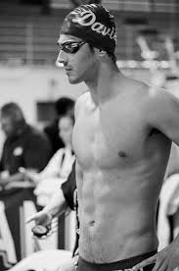www.guardian.co.tt

For the 5th consecutive Day of these World Junior Championships Dylan Carter of Trinidad and Tobago has progressed again from the morning heats to the next round. And he did so in spectacular fashion as motored through the 100 metre freestyle to stop the watch in 49.93**. In doing so he obliterated the 50.67 PB he did to set the 15-17 CARIFTA earlier in Kingston.** He went out in a swift 24.10 and came back in 25.83. There few juniors in the Caribbean region much less the world that has swam that fast at his age. This was underscored by his fifth placed seeding for the semi-finals later this morning.

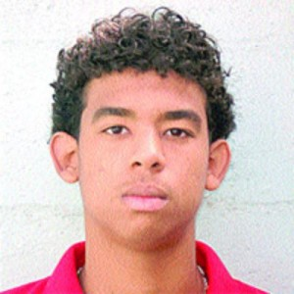usportt.com

Team mate Joshua Romany got himself into another semi – final by taking 16th spot from the heats. Romany clocked 5.11. The best 100 metre freestyle result for him since he lifted the 15-17 CARIFTA title in 2012.

Fifty metre freestyle King Renzo Tjon-A-Joe of Suriname missed the semi- finals when he clocked 18th in a time of 51.16.

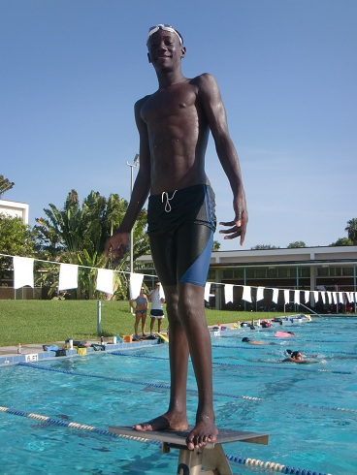www.davienadadores.com

Sidrell Williams who was until recently conditioned by Y Speedos Head Coach Michael Wilson before his late summer move to Florida clocked 55.68 in this event for 66th spot.

Anthony Morrison-Vincent